## Overall Summary:

* Year = 2018
  + Why 2018? Q2’s data is only provided in this year, so we had to stick to it
  + Caused problems of small dataset but at least it is consistent
* Theme = Civil and Political Rights (Q1, Q3), with focus to People at Risk (Q2), in countries around the globe
  + Why this theme? These rights and these groups of peop;e are especially relevant in today’s political climate
  + Why around the globe? Data is from around the world, it is good to gain a better understanding of the world, not just the US or any specific country
* Q1 - broad: comparing whole political systems and government types around the globe
* Q2 - specific: comparing specific groups/communities of people
  + Mention if this is country specific
* Q3 - bringing together Q1 (broad, about safety from the state) and Q2 (specific, about rights to assembly aka union) to check for any correlation or external factor

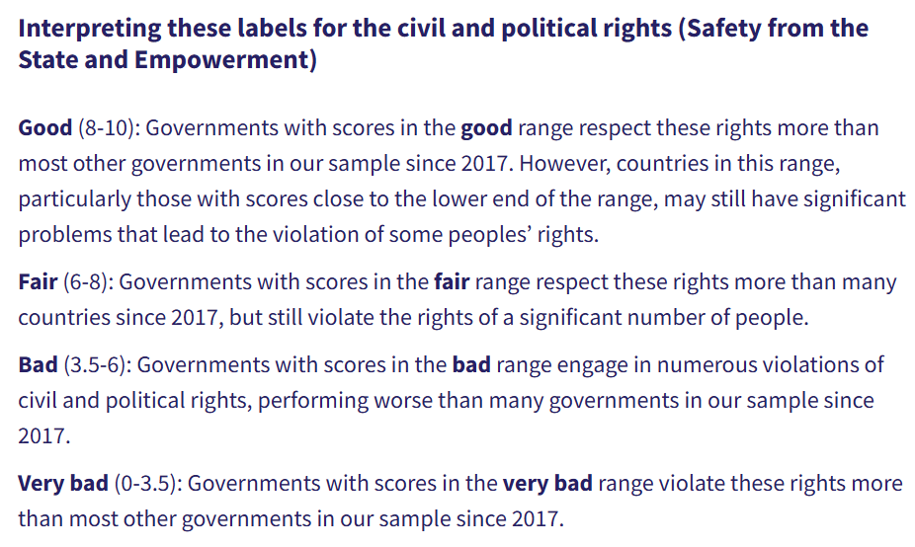

* More about each question below:

## Question 1: Compare various countries’ rights to death penalty execution (dpex) and the right to participate in government. **dpex and polplart**, to their right to freedom from torture and ill treatment **(tort)** in **HRMI Civil and Political Rights (CPR) dataset.**

**Broad Question: What patterns exist between different civil and political rights across countries?**

**Narrow Question:What variations exist among countries in 2018 in promoting political participation, providing death penalty protections, and preventing torture?**

* Variables used:
  + **year(2018)**
  + **country**
  + **dpex-** Right to freedom from death penalty execution
  + **poplart-Right** to participate in government
  + **Tort**-Right to freedom from torture and ill-treatment
* Plots with 3-layers(x axis =**polpart_mean**, y axis = **dpex_mean**, size of dot = **tort_mean)**
* Results:
  + positive correlation found between the right to participate in government and the right to freedom from death penalty execution
  + As both DPEX and POLPART increase, the size of the variable "TORT-Right to Freedom from Torture and Ill-Treatment" also increases, suggesting a relationship between greater rights to participate in government and protection from the death penalty with stronger rights against torture and ill-treatment.
* Summary: Based on our analysis of the 2018 data for the Civil and Political Rights dataset, our scatterplot shows the relationship between the right to participate in government and the right to freedom from the death penalty across different countries. Every country is represented by a circle, and the size and color reflects the level of freedom from torture, which the lighter and larger circles indicating greater freedom from torture. The countries with higher values on the x- and y-axes have stronger protections for political participation and freedom from the death penalty. This visualization showcases which countries rank higher in political and deth penalty rights and how torture levels vary between them.

**Q1:**

**Code for all options (includes importing libraries, loading dataset, and filtering columns to the year 2018)**

**import pandas as pd**

**import matplotlib.pyplot as plt**

**import plotly.graph_objects as go**

**cprq1 = pd.read_csv("C:/Users/Daisy/OneDrive - Emory/Desktop/QTM 151/HRMI_Data_Download_2024_release/HRMI_Data_Download_2024.6.20/csv files/cpr.csv") *# Updated file path (will need to be changed individually to work for each person’s code)***

**print(cprq1.columns)**

**cprq1.head()**

**cpr_2018 = cprq1[cprq1['year'] == 2018]**

**cpr_2018.head()**

**columns_of_interest = ['country', 'year', 'polpart_mean', 'polpart_sd', 'polpart_lo', 'polpart_hi',**

**'dpex_mean', 'dpex_sd', 'dpex_lo', 'dpex_hi', 'tort_mean', 'tort_sd', 'tort_lo', 'tort_hi']**

**cpr_q1_2018_filtered = cpr_2018[columns_of_interest]**

**cpr_q1_2018_filtered.head()**

**cpr_q1_2018_filtered**

**Option 1: Interactive plot color based on tort_mean**

***# Interactive scatter plot with color based on tort_mean***

**fig = go.Figure()**

**fig.add_trace(go.Scatter(**

**x=cpr_q1_2018_filtered["polpart_mean"],**

**y=cpr_q1_2018_filtered["dpex_mean"],**

**mode='markers',**

**text=cpr_q1_2018_filtered['country'],**

**marker=dict(**

**size=cpr_q1_2018_filtered['tort_mean'] * 7,**

**color=cpr_q1_2018_filtered['tort_mean'],**

**colorscale='Viridis',**

**showscale=True,**

**colorbar=dict(**

**title='Mean Torture Level',**

**titleside='right',**

**tickvals=[cpr_q1_2018_filtered['tort_mean'].min(),**

**cpr_q1_2018_filtered['tort_mean'].max()],**

**ticktext=['Low', 'High'] *# label bottom "Low" and top "High"***

**),**

**opacity=0.6**

**),**

**hovertemplate='<b>Country:</b> %{text}<br>' +**

**'<b>Right to Participate in Government:</b> %{x}<br>' +**

**'<b>Freedom from Death Penalty:</b> %{y}<br>' +**

**'<b>Mean Torture Score:</b> %{marker.color}<extra></extra>'**

**))**

***# X and Y axis labels and title***

**fig.update_layout(**

**title={**

**'text': 'Government Participation vs Freedom from Death Penalty and Torture (2018)<br><sup>Higher x-values mean stronger rights; Higher y-values mean stronger freedom from death penalty<br><sup> Lighter color indicates higher torture mean score',**

**'y':0.95,**

**'x':0.5,**

**'xanchor': 'center',**

**'yanchor': 'top'**

**},**

**xaxis=dict(**

**title='Right to Participate in Government (Mean Score)',**

**title_font=dict(size=18),**

**tickfont=dict(size=12)**

**),**

**yaxis=dict(**

**title='Freedom from Death Penalty (Mean Score)',**

**title_font=dict(size=16),**

**tickfont=dict(size=12)**

**),**

**width=1000,**

**height=600,**

**template='plotly_white'**

**)**

**fig.write_html("C:/Users/Daisy/OneDrive - Emory/Desktop/QTM 151/HRMI_Data_Download_2024_release/HRMI_Data_Download_2024.6.20/csv files/cpr_interactive_plot.html")**

**fig.show()**

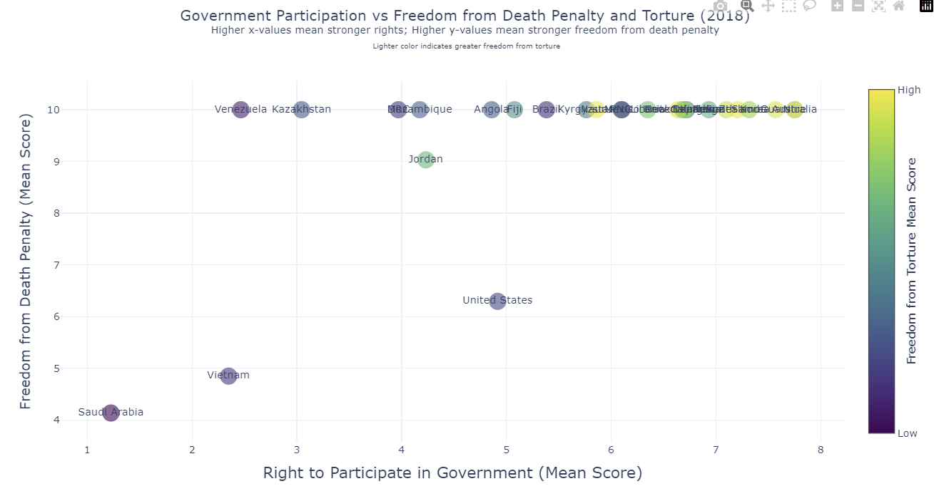

**Option 2: Interactive Scatterplot categorized by country**

**countries = sorted(cpr_q1_2018_filtered['country'].unique())**

***# one trace per country***

**fig = go.Figure()**

**for country in countries:**

**df_subset = cpr_q1_2018_filtered[cpr_q1_2018_filtered['country'] == country]**

**fig.add_trace(go.Scatter(**

**x=df_subset["polpart_mean"],**

**y=df_subset["dpex_mean"],**

**mode='markers',**

**name=country,**

**text=df_subset['country'],**

**marker=dict(**

**size=df_subset['tort_mean'] * 7,**

**color=df_subset['tort_mean'],**

**colorscale='Viridis',**

**showscale=False, *# one global colorbar***

**opacity=0.7**

**),**

**visible=True *# control visibility w/ dropdown***

**))**

***# Dropdown buttons***

**dropdown_buttons = [**

**dict(label="All",**

**method="update",**

**args=[{"visible": [True] * len(countries)},**

**{"title": "Government Participation vs Freedom from Death Penalty and Torture (2018)"}])**

**]**

**for i, country in enumerate(countries):**

**visibility = [j == i for j in range(len(countries))]**

**dropdown_buttons.append(**

**dict(label=country,**

**method="update",**

**args=[{"visible": visibility},**

**{"title": f"{country}: Participation vs Death Penalty Freedom"}])**

**)**

***# Layout***

**fig.update_layout(**

**updatemenus=[**

**dict(**

**active=0,**

**buttons=dropdown_buttons,**

**direction="down",**

**x=1.12,**

**xanchor="left",**

**y=1.15,**

**yanchor="top"**

**)**

**],**

**title={**

**'text': 'Government Participation vs Freedom from Death Penalty and Torture (2018)<br><sup>Higher scores mean stronger rights; bigger circle=greater freedom from torture.</sup>',**

**'y':0.95,**

**'x':0.5,**

**'xanchor': 'center',**

**'yanchor': 'top'**

**},**

**xaxis_title="Right to Participate in Government (Mean Score)",**

**yaxis_title="Freedom from Death Penalty (Mean Score)",**

**xaxis_tickangle=0,**

**width=1000,**

**height=600,**

**template="plotly_white"**

**)**

***# Add the single colorbar (legend) separately***

**fig.update_layout(**

**coloraxis_colorbar=dict(**

**title='Mean Torture Level',**

**tickvals=[cpr_q1_2018_filtered['tort_mean'].min(), cpr_q1_2018_filtered['tort_mean'].max()],**

**ticktext=['Low', 'High']**

**)**

**)**

**fig.show()**

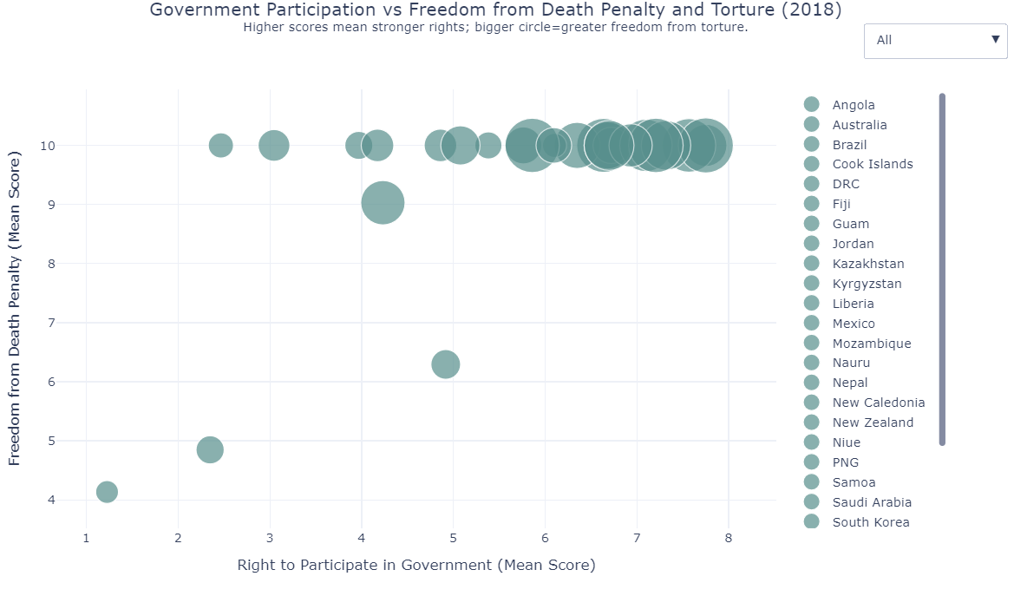

## Question 2: (2018 only) Compare various countries’ rights to form unions and their rights to favourable work conditions. **jobcond and union in HRMI People at Risk (PaR) Dataset.**

* Higher proportion indicates a higher risk for that respective right to be compromised
* Pg 5,6, and 7 of codebook
* Variables used:
  + **year**: 2018
  + **country**
  + **jobcond:** Right to just and favourable work conditions
  + **union:** Rights to form and join unions to go on strikes
* Groups I looked at (3 subplots and 1 large plot, dropdown menu to change between them)
  + Women
  + LGBTQIA+
  + Members of Labor Unions
    - Chose to look at the effect son members of labour unions because this could show signs of corrupt government, active suppression of efforts to improve working conditions, and the fact that union members fight for all people’s right to have a good working environment (not just their union members)
* Summary of findings: Based on our analysis of the 2018 data, our scatter plot visualizes the proportion of at-risk individuals for both job conditions and union rights across three distinct groups: women, LGBTQIA+ people, and union advocates. This plot highlights the countries where these groups face varying levels of risk, with a focus on the correlation between the two aspects. The "good zone," marked in light green, identifies countries that perform “well” in protecting both job conditions and union rights, with lower proportions indicating better conditions. Countries falling within this zone are those with a relatively lower risk of losing both job protections and union rights. The dropdown filter allows for an exploration of the data by each group, providing insights into how each group is represented across different countries. The use of distinct colors for each group (purple for women, teal for LGBTQIA+, and crimson for union advocates) enhances the visual clarity, making it easier to interpret the findings and compare risks among groups.
* Remember: For my interactive plot, we also *have* to submit the html file for the figure so that she can actually view the graph when we submit it to github. The file should be called “Question2.html”

**Code:**

**# Load your data**

**PaR = pd.read_csv('people_at_risk.csv')**

**# Grouped data**

**PaR_2018 = PaR[PaR['year'] == 2018]**

**# Select only needed columns**

**columns_of_interest = ['country',**

**'jobcond_atrisk_prop10', 'union_atrisk_prop10',**

**'jobcond_atrisk_prop11', 'union_atrisk_prop11',**

**'jobcond_atrisk_prop19', 'union_atrisk_prop19']**

**# Narrow down and clean**

**PaR_subset = PaR_2018[columns_of_interest].dropna()**

**# Rename columns**

**PaR_focus = PaR_subset.rename(columns={**

**'jobcond_atrisk_prop10': 'jobcond_women_proportion',**

**'union_atrisk_prop10': 'union_women_proportion',**

**'jobcond_atrisk_prop11': 'jobcond_lgbtq_proportion',**

**'union_atrisk_prop11': 'union_lgbtq_proportion',**

**'jobcond_atrisk_prop19': 'jobcond_unions_proportion',**

**'union_atrisk_prop19': 'union_unions_proportion'**

**})**

**# Groups and labels**

**groups = ['women', 'lgbtq', 'unions']**

**group_labels = {**

**'women': 'Women and/or Girls',**

**'lgbtq': 'LGBTQIA+ People',**

**'unions': 'Union Advocates'**

**}**

**# Define distinct colors**

**colors = {**

**'women': 'purple', # Purple**

**'lgbtq': 'cyan', # Teal**

**'unions': 'red' # Red**

**}**

**# Create the figure**

**fig = go.Figure()**

**# Add traces for each group**

**for group in groups:**

**fig.add_trace(go.Scatter(**

**x=PaR_focus[f'jobcond_{group}_proportion'],**

**y=PaR_focus[f'union_{group}_proportion'],**

**mode='markers',**

**marker=dict(color=colors[group], size=10, line=dict(width=1, color='black')),**

**text=PaR_focus['country'],**

**hovertemplate=(**

**'<b>%{text}</b><br>' +**

**'Work Conditions At-Risk (Proportion): %{x:.2f}<br>' +**

**'Union Rights At-Risk (Proportion): %{y:.2f}<extra></extra>'**

**),**

**name=group_labels[group],**

**visible=True**

**))**

**# Dropdown buttons**

**dropdown_buttons = [**

**dict(label="All",**

**method="update",**

**args=[{"visible": [True] * len(groups)},**

**{"title": "At-Risk: Job Conditions vs Union Rights by Group (2018)"}])**

**]**

**for i, group in enumerate(groups):**

**visibility = [j == i for j in range(len(groups))]**

**dropdown_buttons.append(**

**dict(label=group_labels[group],**

**method="update",**

**args=[{"visible": visibility},**

**{"title": f"At-Risk: {group_labels[group]} - Work Conditions vs Union Rights (2018)"}])**

**)**

**# Update the layout**

**fig.update_layout(**

**updatemenus=[**

**dict(**

**active=0,**

**buttons=dropdown_buttons,**

**direction="down",**

**x=1.15,**

**xanchor="left",**

**y=1.1,**

**yanchor="top"**

**)**

**],**

**title="At-Risk: Work Conditions vs Union Rights by Group (2018)",**

**template="plotly_white",**

**height=600,**

**width=1200,**

**xaxis=dict(**

**title="At Risk: Right to Fair and Just Work Conditions (Proportion)",**

**range=[-0.05, 0.8]**

**),**

**yaxis=dict(**

**title="At Risk: Right to Union (Proportion)",**

**range=[-0.05, 0.7]**

**),**

**shapes=[**

**dict(**

**type="rect",**

**x0=0, y0=0,**

**x1=0.2, y1=0.2, # You can adjust this to whatever "good" looks like**

**fillcolor="lightgreen",**

**opacity=0.3,**

**layer="below",**

**line_width=0**

**)**

**],**

**)**

**# TRENDS**

**# Further up and to the right is bad**

**# Further down and to the left is good**

**# Green zone highlights countries that are doing well in terms of protecting these rights. Countries with all 3 groups in the green box are doing great!**

**# Save and show**

**fig.write_html("figures/with_dropdown_filter.html")**

**fig.show()**

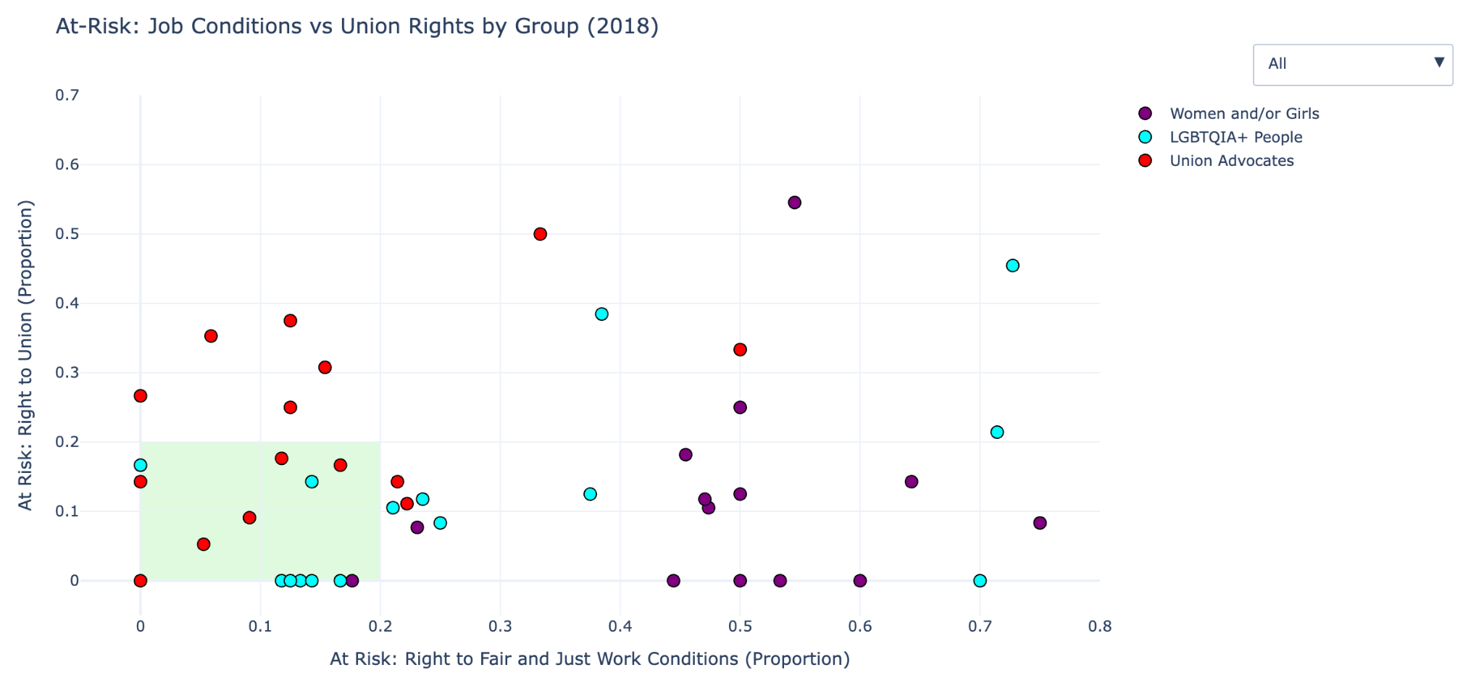

## Question 3: Compare various countries’ right to assembly and association, such as with protest groups or unions (**assem)** and right to opinion and expression, such as right to free speech (**express)** to their overall right to safety from the state, described in detail below (**physint),** in **HRMI Civil and Political Rights (CPR) Dataset**

* Numbers mean “intensity of respect for that right”
* Pg 4 of Codebook: <https://www.dropbox.com/scl/fi/erkmpbo2zuwc2y46e85nl/HRMI_Data_Download_2024_release.zip?dl=0&e=1&file_subpath=%2FHRMI_Data_Download_2024_release%2FHRMI_Data_Download_2024.6.20%2FHRMI+dataset+codebook+2024.6.20.pdf&rlkey=oyo7qw9kvxi12he2hmmx6qwvv>
* Variables Used:
  + **year** (2018)
  + **country**
  + **physint** - Overall right to safety from the state, i.e. Physical Integrity Rights - Based on scores for arrest, disap, dpex, exkill, and tort
    - arrest - Right to freedom from arbitrary or political arrest and imprisonment
    - disap - Right to freedom from disappearance
    - dpex - Right to freedom from death penalty execution
    - exkill - Right to freedom from extrajudicial execution
    - tort - Right to freedom from torture and ill - treatment
  + **assem** - Right to assembly and association
  + **express** - Right to opinion and expression
* Plots with 3-layers(x axis = **assem_mean/lo/hi**, y axis = **express_mean/lo/hi**, size of dot = **physint_mean/lo/hi** ):
  + **"right"_mean** - average intensity score (purple)
  + **"right"_lo** - 10th percentile (red)
  + **"right"_hi** - 90th percentile (green)
* Results:
  + positive correlation found between the right to assembly and the right to expression
  + Makes sense because both of these^ are related to overall right to empowerment
  + Can also see dot SIZES increasing in a positive correlation to **physint**, suggesting that right to empowerment and safety from the state are positively related around the world

Q3: Olivia

*# Import necessary libraries*

import **pandas** as **pd** *# For non-plot commands*

import **matplotlib**.**pyplot** as **plt** *# For non-interactive plots*

import **plotly**.**graph_objects** as **go** *# For interactive plots*

*# Import necessary data*

*cpr =* ***pd****.****read_csv****("csv files/cpr.csv") # CPR stands for Civil and Political Rights*

*# Check column names*

***print****(cpr.columns)*

*# See the df*

*cpr.****head****()*

*# Clean df to take data from only 2018*

*cpr_2018 = cpr[cpr['year']* ***==*** *2018]*

*# See the new df*

*cpr_2018.****head****()*

*# Further clean dataset to only include relevant data from Q3: Compare various countries’ assem to physint*

*cpr_2018_q3 = cpr_2018[['country', 'year', 'assem_mean', 'assem_sd', 'assem_lo', 'assem_hi', 'express_mean', 'express_sd', 'express_lo', 'express_hi', 'physint_mean', 'physint_sd', 'physint_lo', 'physint_hi']]*

*# Check if it worked*

***print****(cpr_2018_q3.columns)*

*# See the df*

*cpr_2018_q3*

*# Remove any rows with missing values for any column*

*cpr_final = cpr_2018_q3.****dropna****()*

***print****(cpr_final.columns)*

*# See the df*

*cpr_final*

*# Make a scatterplot to compare various countries in 2018*

***plt****.****style****.****use****('fivethirtyeight')*

***plt****.****figure****(figsize=(15, 9))*

***plt****.****scatter****(x=cpr_final["assem_mean"], y=cpr_final["express_mean"], s=cpr_final["physint_mean"]****\*****100, color='purple', alpha=0.5, label='Average Intensity Score')*

***plt****.****scatter****(x=cpr_final["assem_lo"], y=cpr_final["express_lo"], s=cpr_final["physint_lo"]****\*****100, color='red', alpha=0.5, label='10th Percentile')*

***plt****.****scatter****(x=cpr_final["assem_hi"], y=cpr_final["express_hi"], s=cpr_final["physint_hi"]****\*****100, color='green', alpha=0.5, label='90th Percentile')*

*# Need to scale up the sizes of the dots so that noticable size differences can actually be seen*

***plt****.****xlabel****("Right to Assembly and Association")*

***plt****.****ylabel****("Right to Opinion and Expression")*

***plt****.****legend****(loc='upper left', bbox_to_anchor=(1, 1))*

***plt****.****title****("Rights to Assembly and Freedom of Expression Compared to Physical Integrity Rights in Various Countries in 2018")*

***plt****.****show****()*

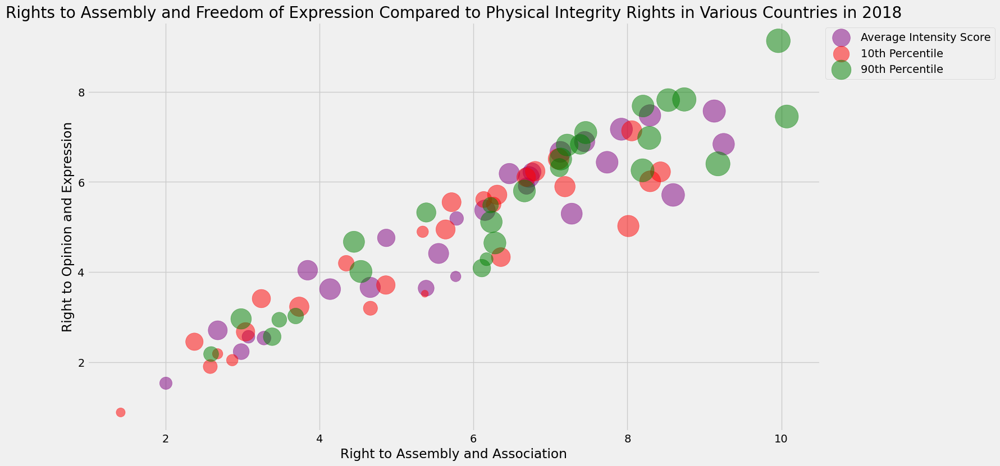

*# Create an interactive plot as well*

*fig =* ***go****.****Figure****()*

*# Add "right"_mean data*

*fig.****add_trace****(****go****.****Scatter****(*

*x=cpr_final["assem_mean"],*

*y=cpr_final["express_mean"],*

*mode='markers',*

*marker=****dict****(*

*size=cpr_final["physint_mean"]* ***\**** *5, # adjust scaling*

*color='purple',*

*opacity=0.5,*

*),*

*name='Average Intensity Score',*

*text="Country: "+cpr_final["country"], # hover text showing country name*

*hoverinfo='text+x+y',*

*hovertemplate=(*

*"Average Score for Right to Assembly and Association: %{x}<br>" +*

*"Average Score for Right to Opinion and Expression: %{y}<br>" +*

*"Country: "+cpr_final["country"]****+***

*"<extra></extra>" # <extra></extra> removes the secondary hover box*

*)))*

*# Add "right"_lo (10th percentile) data*

*fig.****add_trace****(****go****.****Scatter****(*

*x=cpr_final["assem_lo"],*

*y=cpr_final["express_lo"],*

*mode='markers',*

*marker=****dict****(*

*size=cpr_final["physint_lo"]* ***\**** *5,*

*color='red',*

*opacity=0.5,*

*),*

*name='10th Percentile',*

*text="Country: "+cpr_final["country"],*

*hoverinfo='text+x+y',*

*hovertemplate=(*

*"Bottom 10% Score for Right to Assembly and Association: %{x}<br>" +*

*"Bottom 10% Score for Right to Opinion and Expression: %{y}<br>" +*

*"Country: "+cpr_final["country"]****+***

*"<extra></extra>" # <extra></extra> removes the secondary hover box*

*)))*

*# Add "right"_hi (90th percentile) dots*

*fig.****add_trace****(****go****.****Scatter****(*

*x=cpr_final["assem_hi"],*

*y=cpr_final["express_hi"],*

*mode='markers',*

*marker=****dict****(*

*size=cpr_final["physint_hi"]* ***\**** *5,*

*color='green',*

*opacity=0.5,*

*),*

*name='90th Percentile',*

*text="Country: "+cpr_final["country"],*

*hoverinfo='text+x+y',*

*hovertemplate=(*

*"Top 10% Score for Right to Assembly and Association: %{x}<br>" +*

*"Top 10% Score for Right to Opinion and Expression: %{y}<br>" +*

*"Country: "+cpr_final["country"]****+***

*"<extra></extra>" # <extra></extra> removes the secondary hover box*

*)*

*))*

*# Customize the layout*

*fig.****update_layout****(*

*title="Score for Empowerment to the Overall Right to Safety from the State in Various Countries in 2018",*

*xaxis_title="Right to Assembly and Association",*

*yaxis_title="Right to Opinion and Expression",*

*legend_title='Intensity of Respect Dataset',*

*legend=****dict****(x=1.05, y=1),*

*width=1000,*

*height=600,*

*template='plotly_white'*

*)*

*# Check the plot*

*fig.****write_html****("csv files/q3.html")*

*fig.****show****()*